**Ec2 With AWS CLI**

1. Download

**Link:** [**https://docs.aws.amazon.com/cli/latest/userguide/getting-started-install.html**](https://docs.aws.amazon.com/cli/latest/userguide/getting-started-install.html)

1. 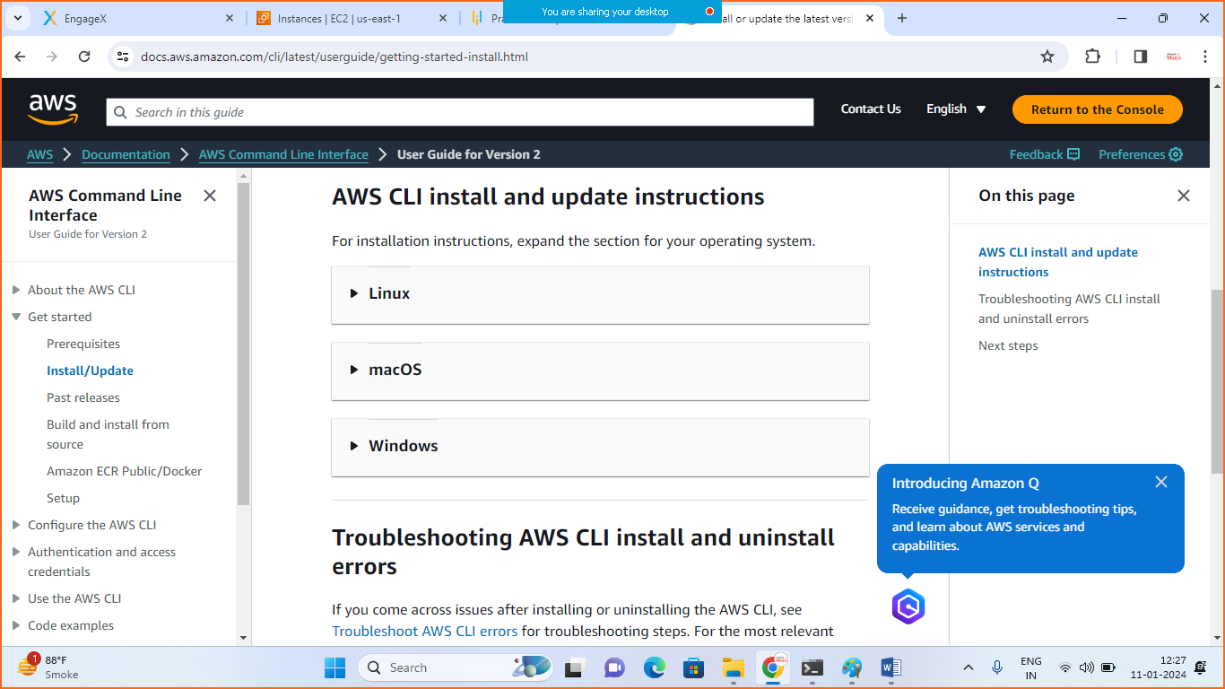
2. Choose your operating system

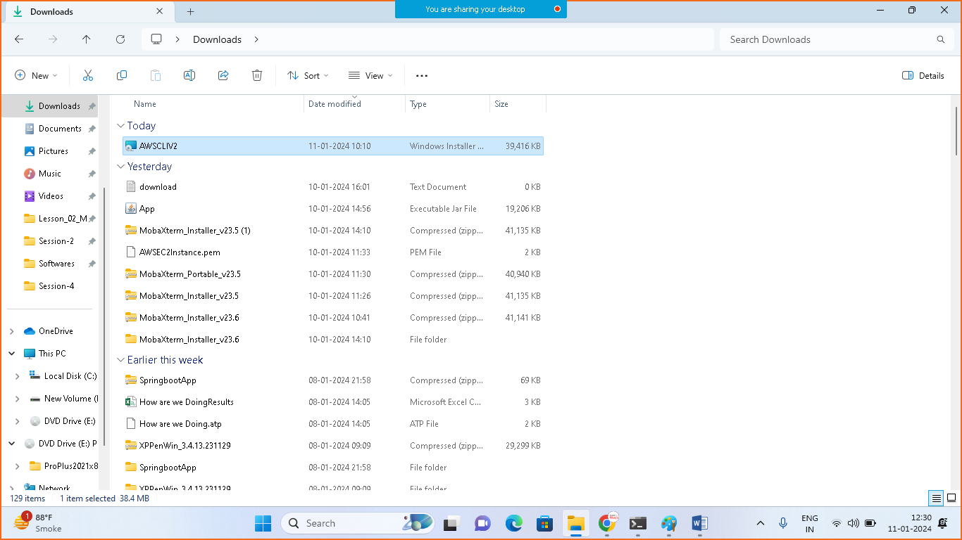

1. Run the Installer

* Open cmd

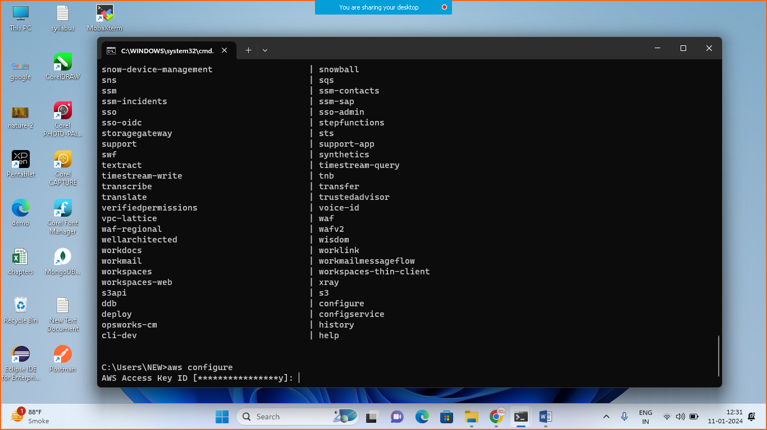

Write :

* aws configure

1. **Goto aws > I am>**

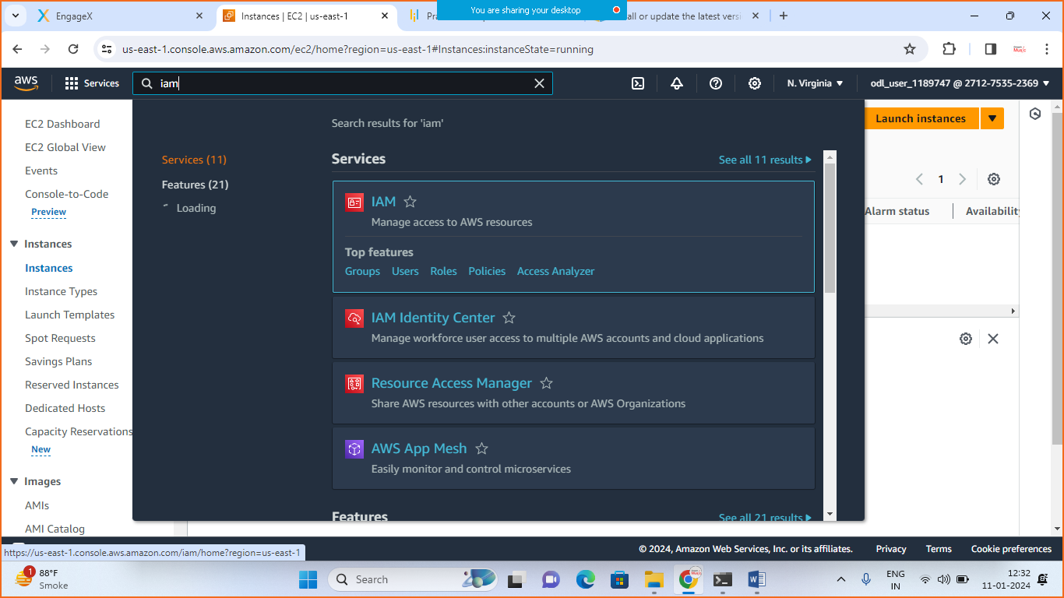

* Click on users

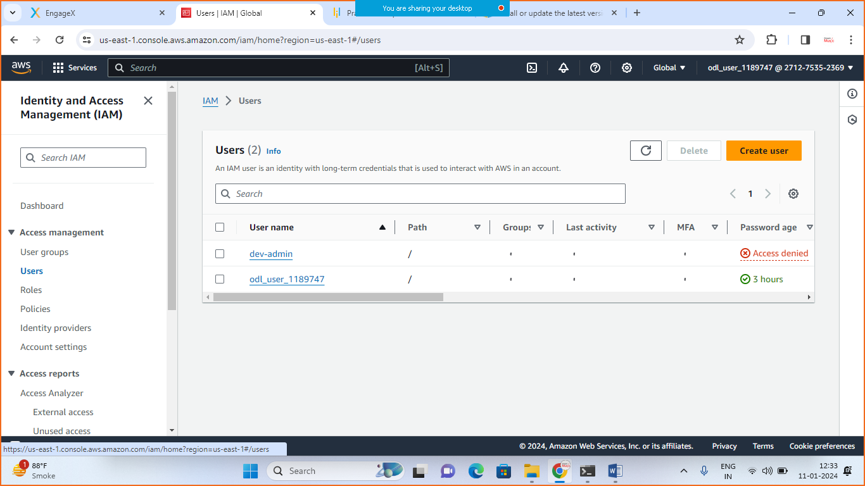

* Click on old_user_1189747 (in your case the name will be different)

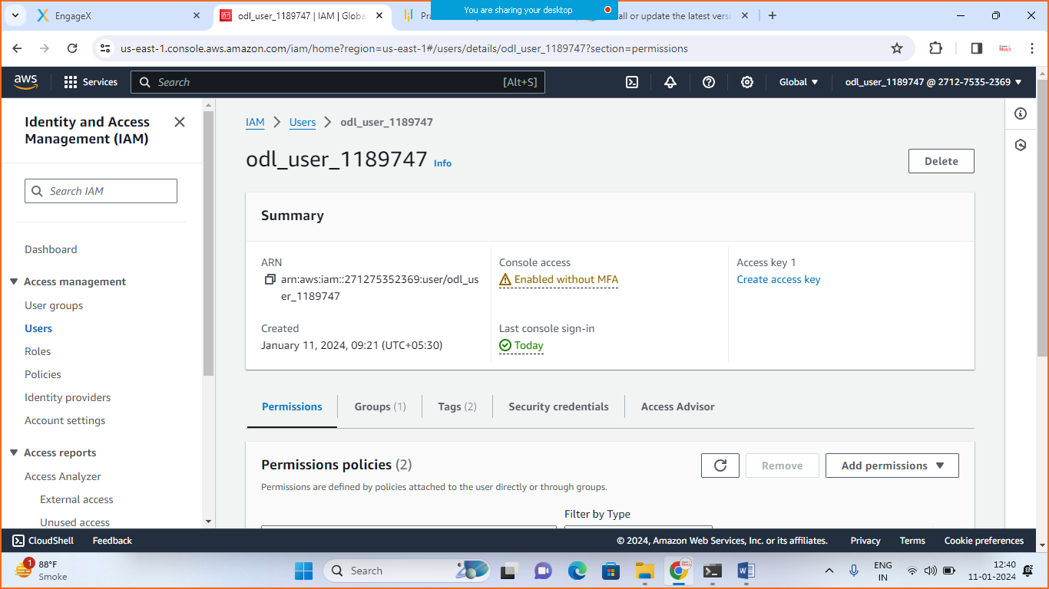

* Create the ACCESS_KEY Or if the key is already prepared copy the key

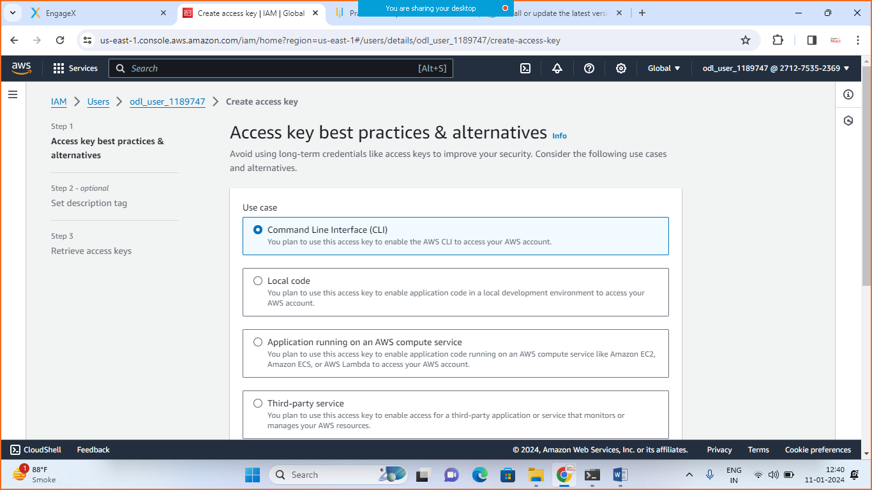

* Check the checkbox and next
* Create / activate key

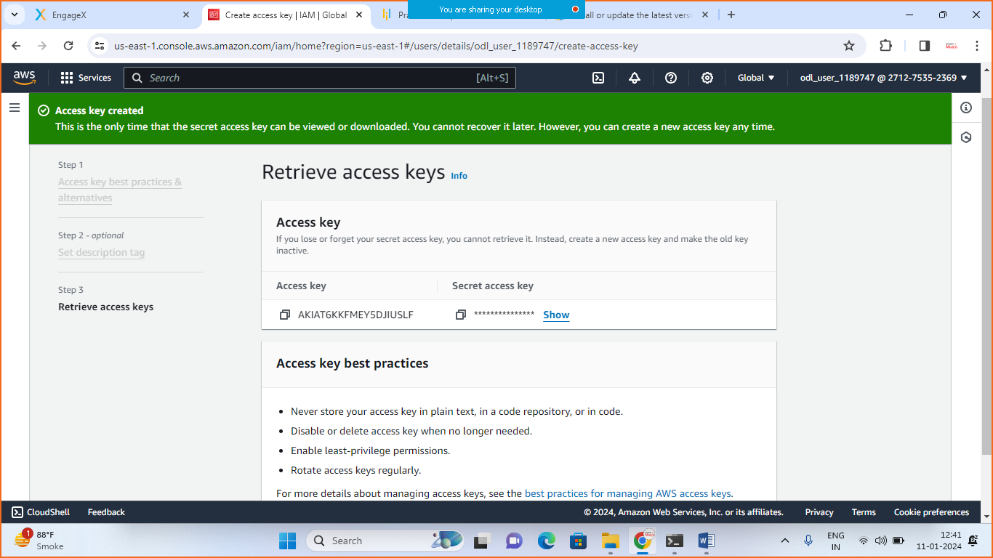

* Go to the cmd and paste access key and security key

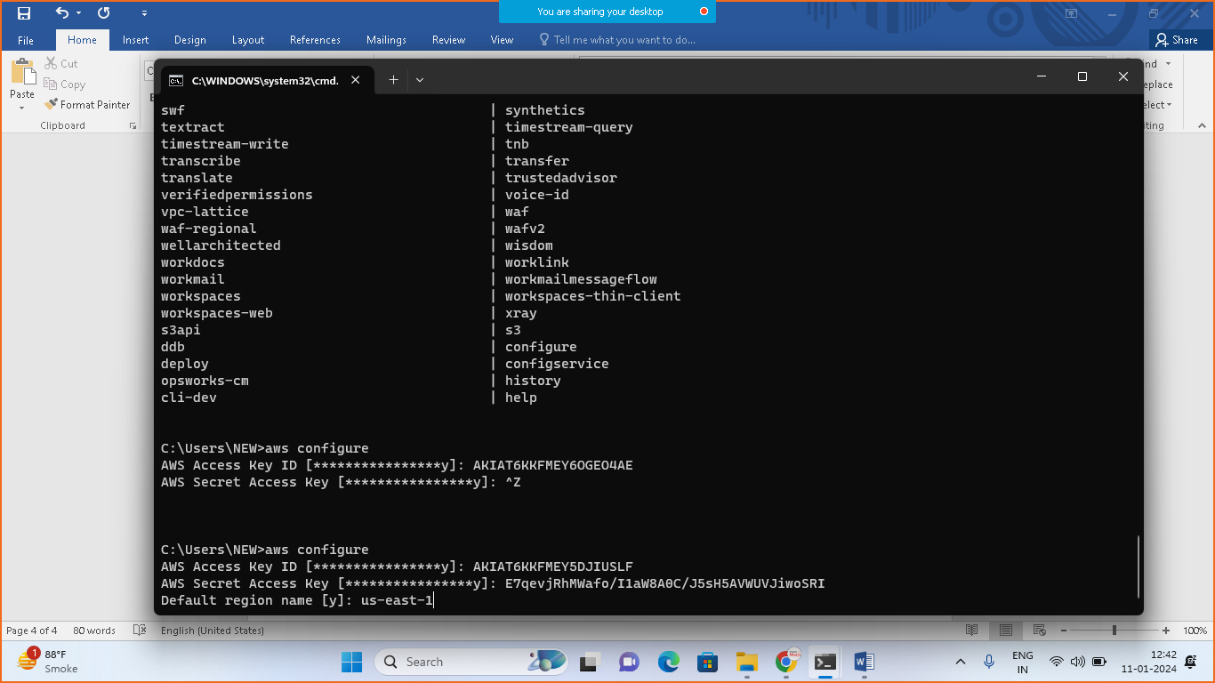

1. Give the region name :us-east-1
2. 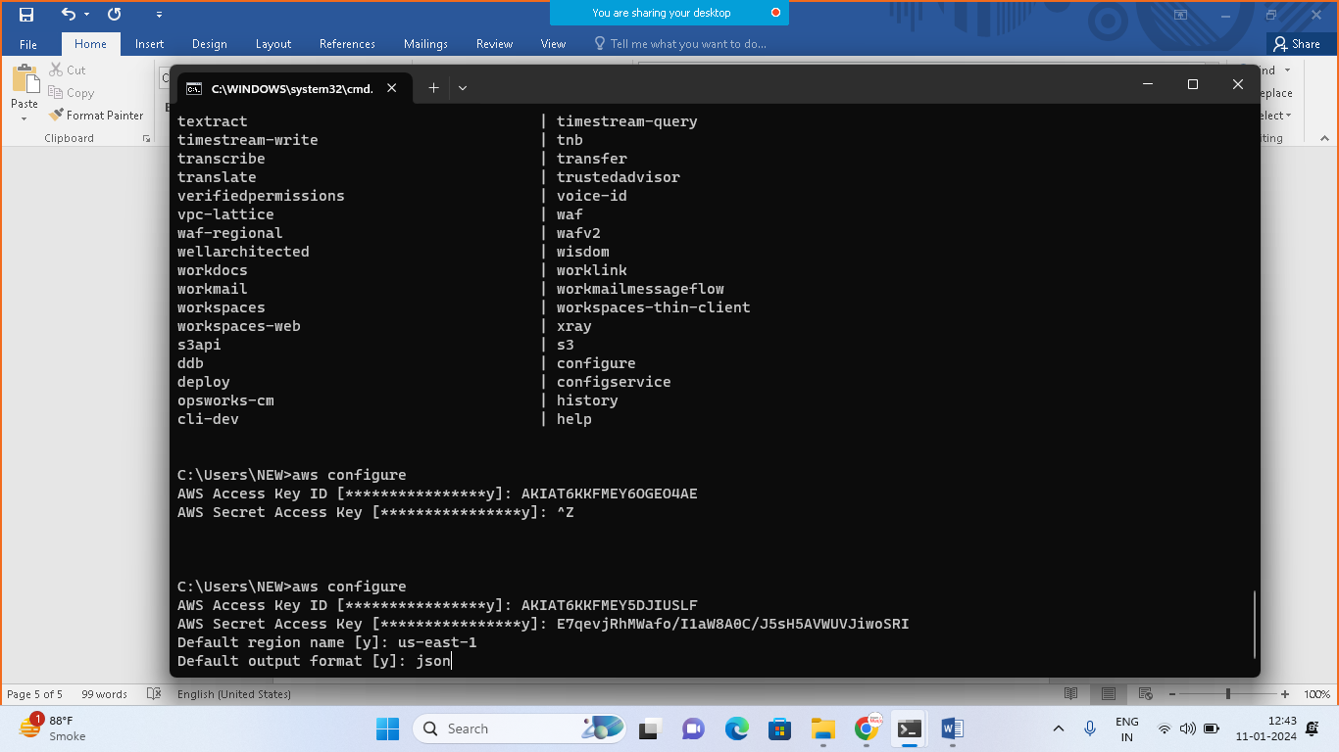
3. Formate option: json
4. **Now got aws> ec2 instance>**

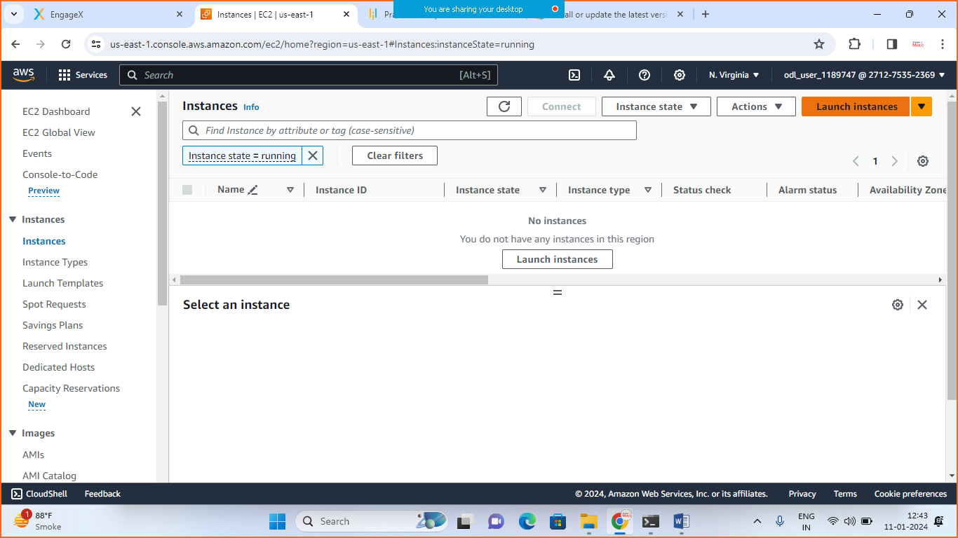

* Generate instance
* Goto notwork settings

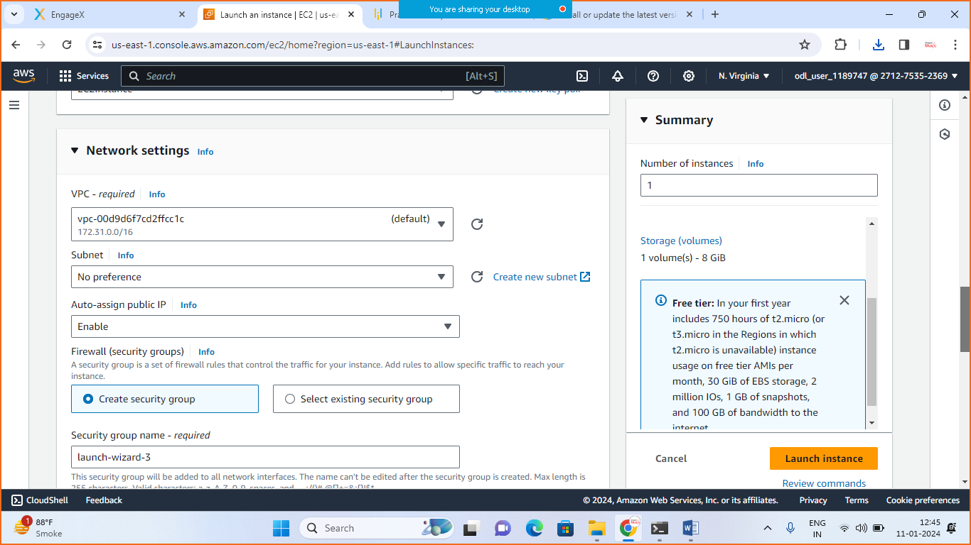

* Edit and add security group rule

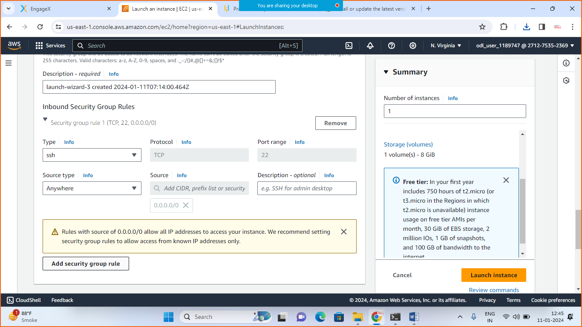

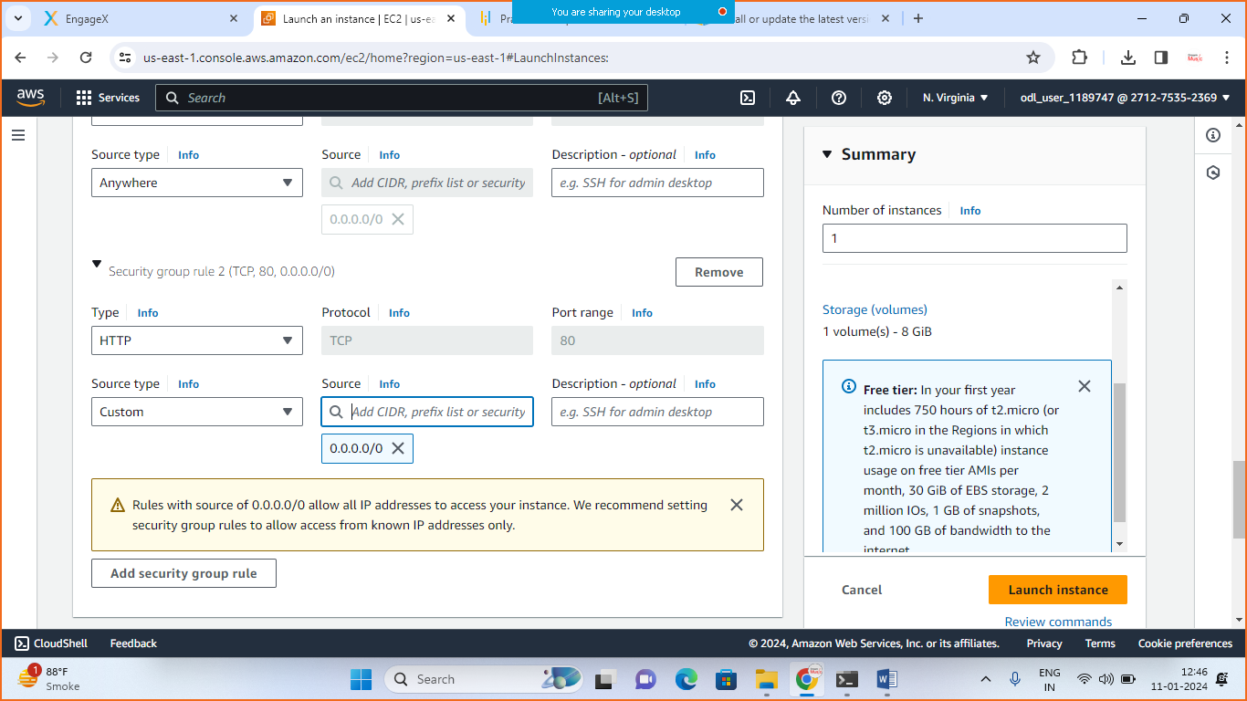

* Add another rule

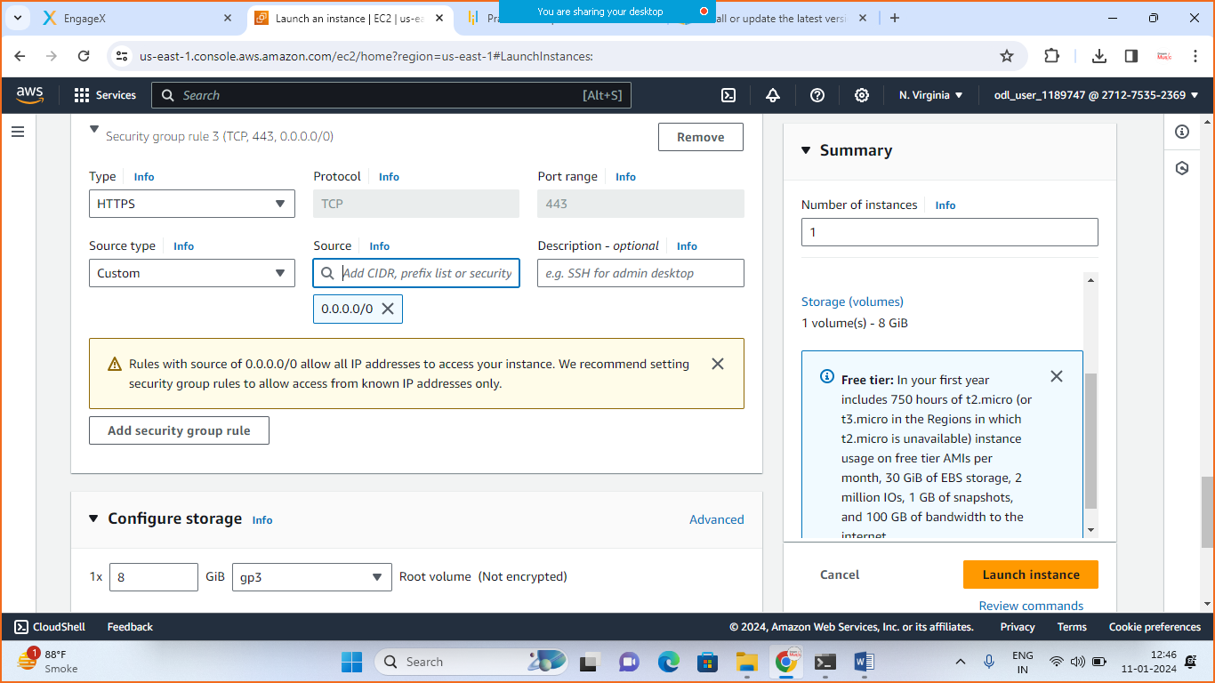

* Launch the instance

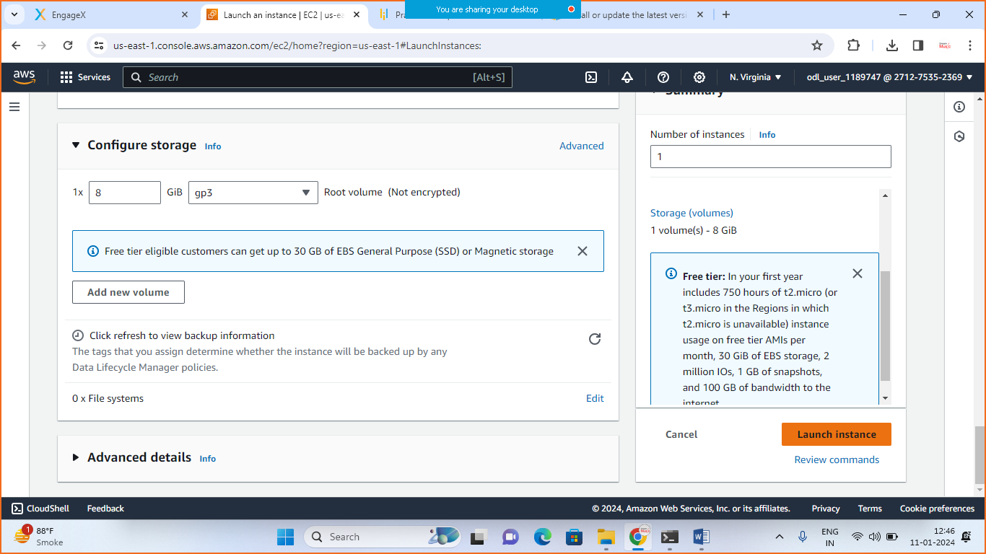

* goto>ec2>instances>choose your instance>connect>

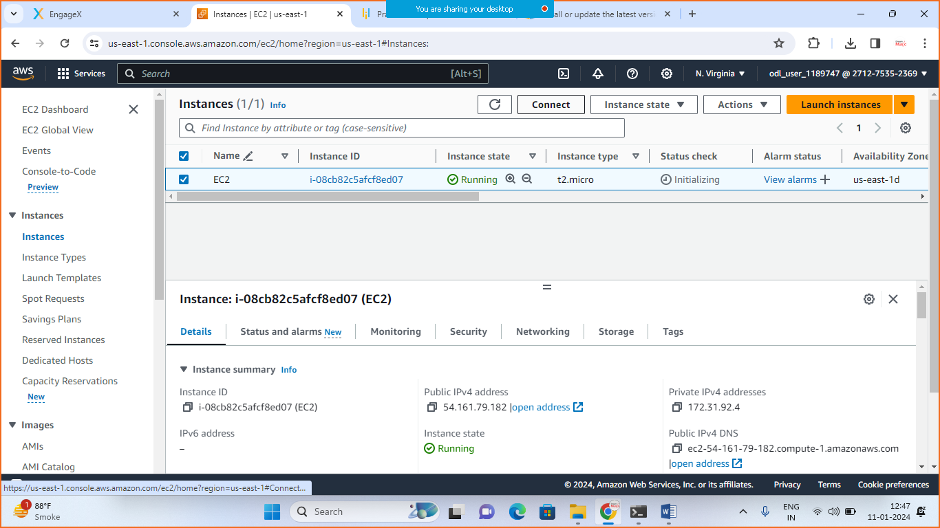

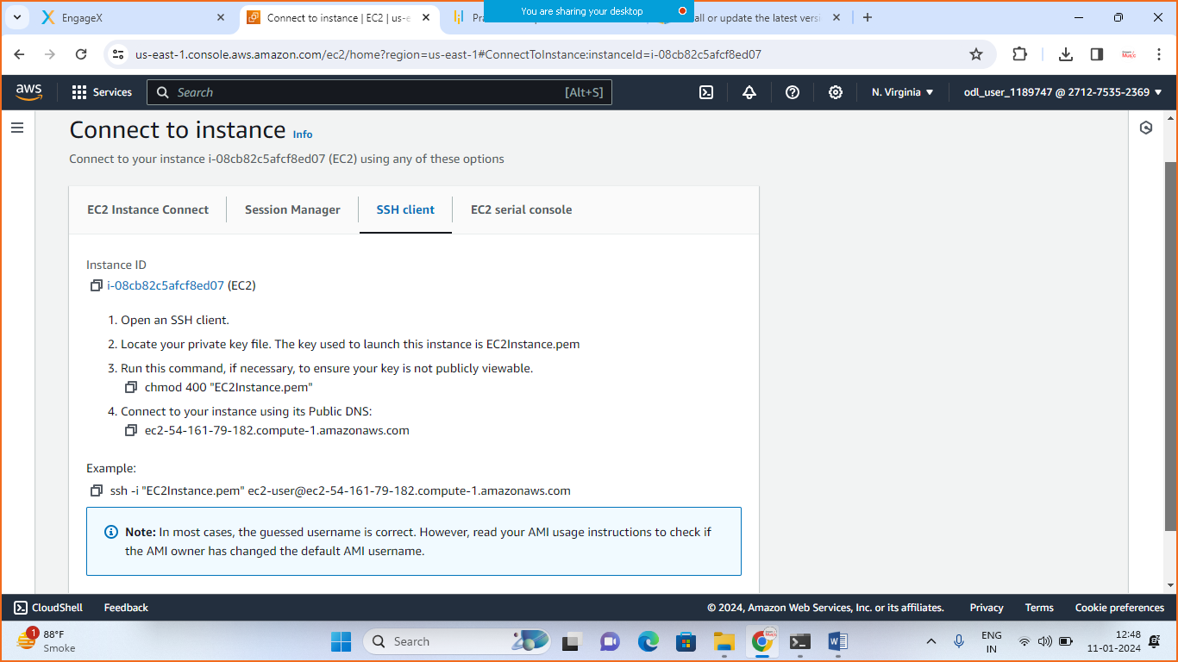

* Goto>SSH and >copy Example Key
* Now comeback to your cmd move to your folder where you have saved .pem key

[For me I have saved in downloads folder so I will move to downloads folder]

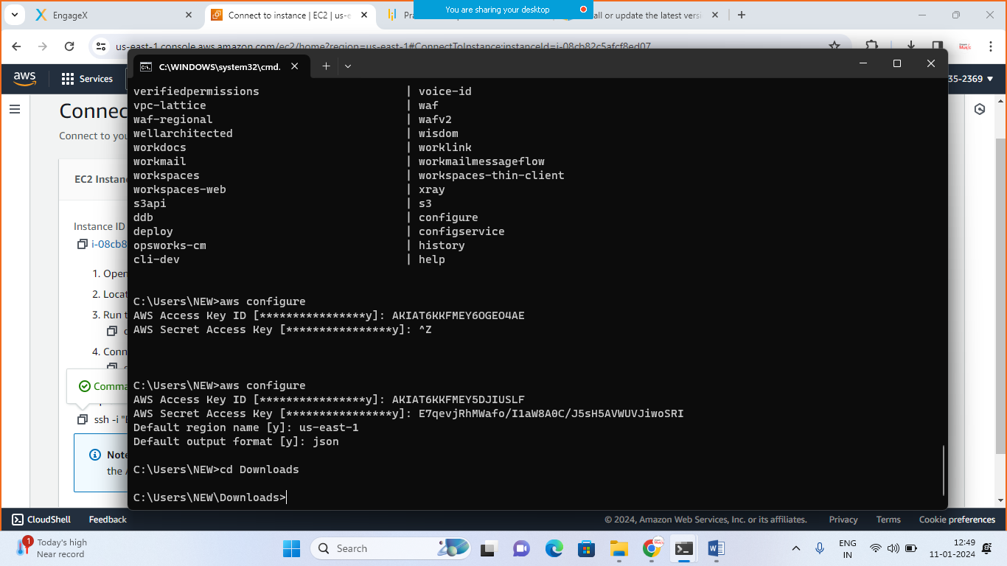

* Paste the example key there

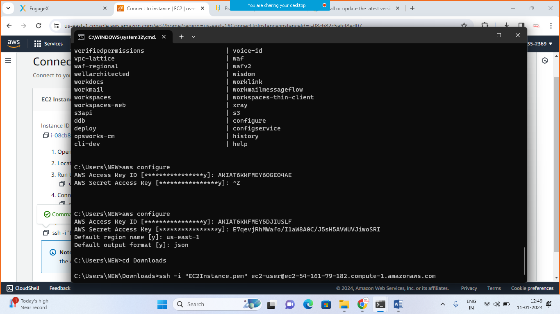

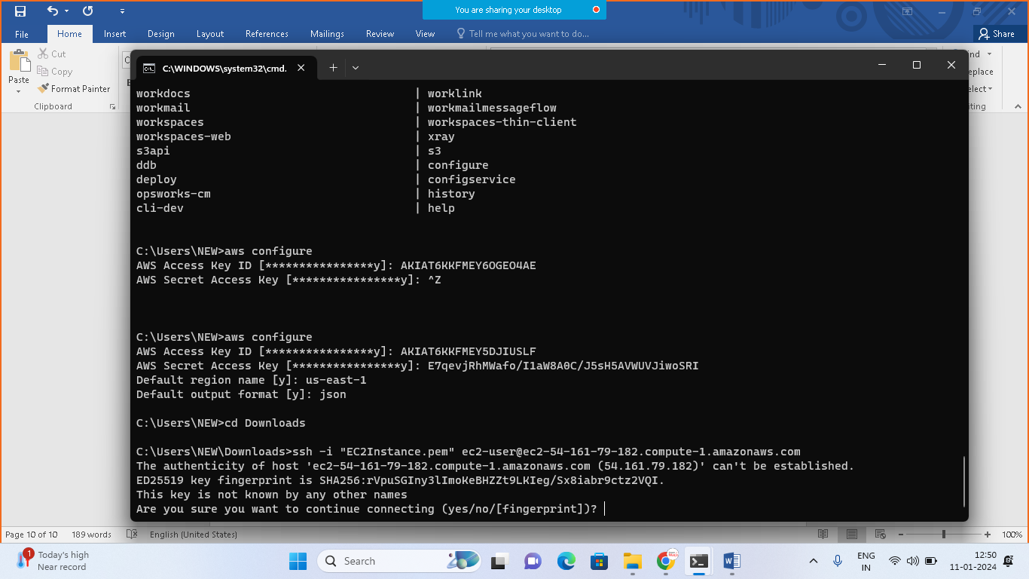> type yes + enter

1. And finally you are connected with AWS Ec2 instance

